





**COMPETENCY**

**WORKSHOPS**

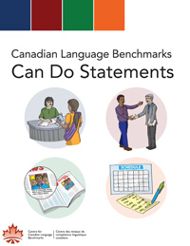

**8 Workshops ...**

**10 Study Sessions ...**

**All 4 Competencies**



**1 Where Am I**

**Use them … transform them … have fun with them!**

**Determining Student Competency Levels**

*This should be done before starting the series of competency workshops. Students will become aware of what their actual competency levels are in each of the four competencies; speaking, listening, reading and writing*

* 1. Teacher introduces the ESL Level Checklists (Can Do Checklists) found on the internet at:

<http://www.language.ca/index.cfm?Voir=sections&Id=17369&M=4038&Repertoire_No=2137991327>

* 1. A student may be in ANG-4036, but that does not guarantee that all of his competencies are at that level. Depending upon the approximate levels of students, introduce and compare the differences between a few of the competency abilities in one or two competencies (ex: Speaking, Level 2 and Level 3; Writing, Level 4 and Level 5)
  2. Teacher explains how beneficial it is to be aware of actual competency levels, and to then set future competency goals
  3. Teacher introduces possible tests for competency measuring from the ‘TEST YOURSELF IN ENGLISH’ page
  4. Students take the tests and discover their competency levels. It is not uncommon that a student may not be at the same level in all competencies (ex: Speaking, Level 3; Reading Level 2, etc.)
  5. Teacher ensures that each student receives copies of their actual competency levels (all four) and the following level, in order to work toward future competency goals

**The BEST Way to Learn English**

*****Give students the handout when you reach this part of the workshop. You may want to make a poster an*  *d remind them of these steps from time to time throughout the session. ***2 Vocabulary**

**Helping students build vocabulary resources**

*Students have a difficult time speaking in English if they don’t have the basic words they need. Help your students to increase their confidence by integrating the words and expressions they need to communicate orally with others*

1. Teacher has a Q & A discussion about how the lack of vocabulary can limit a person’s ability to speak with confidence in another language (using humorous personal anecdotes works well)
2. Teacher presents the SMART Notebook presentation ‘2 Vocabulary Competency Workshop’
3. Introduce the ‘Vocabulary Search Checklist’ page and allow students some time to work with the checklist on their own or in groups
4. Take time to visit both of the vocabulary strengthening websites: Duolingo and FreeRice. You should visit and understand how the sites work before presenting them in class
5. It’s a good idea to follow up with this workshop by allowing students to make use of new vocabulary they have discovered in a concrete way: (discussion, board-games, online activities, role-plays, presentations or simulations ... use your ‘teacher creativity’ and have fun with it!)

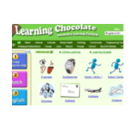

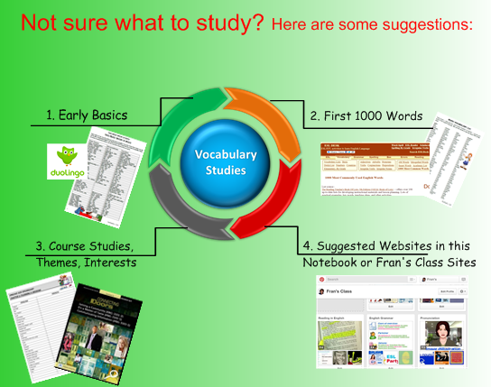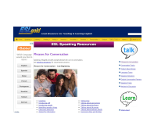** **3 Speaking**

**This Can Be A 2-Part Workshop**

*Speaking is the most necessary and valuable competency to build, yet many students shy away from it altogether. This competency is evaluated at 40% in CBE; therefore the student should spend about 40% of class time building speaking skills. This workshop is an invaluable aid, helping students to communicate better in English at any level.*

**Part 1:**

1. 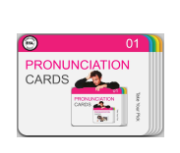Talk with students about why they feel blocked when it comes to speaking in English. Again, anecdotes from your own life may help to break the ice and open up the discussion. You may wish to present a short video clip of an ESL learner trying to convey a message by using competency strategies
2. Teacher presents the SMART Notebook presentation ‘3 Speaking Competency Workshop’
3. Introduce the ‘Speaking (Interaction) Checklist’ page
4. Show students how to chat with Tutor Mike and/or talk to SIRI on the IPad
5. Introduce the PRONUNCIATION CARDS PowerPoint for personal study
6. Give students a conversation goal to work toward (ex: role-plays, chat with an online robot). Allow students some time to work with the checklists before the activity
7. Teacher may decide to have students talk about their speaking experience using the strategies outlined in the workshop and checklist

**Part 2:**

1. All students, whether they are in CBE, DBE or the ‘old programs’ are evaluated on their speaking abilities. Depending upon your curriculum and class planning, you may decide to present the second checklist to your students
2. The ‘Smarties Talk’ activity is very popular with students and offers a great opportunity for reluctant speakers to break the ice and talk to others
3. 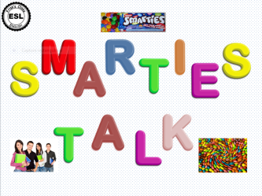Teacher presents the ‘3 Oral Exam Task Checklist’ and invites students to set up a date for their first Oral Exam. Good luck!

**4 Listening**

*Listening is an essential part of acquiring information and increasing speaking skills. Good listening is key to reinvestment. An active listener obtains data and reinvests it into a spoken or written text. An interactive listener hears a spoken text in a conversation, quickly processes the information, and reinvests this information by responding with a rational reply. Students will be able to build both types of listening skills with this workshop.*

1. Hearing a message correctly makes all the difference! A funny way of introducing this workshop is to talk about the ‘Misunderstood Song Lyric Syndrome’. We’ve all done it. Singing along with a song we love, a friend points out that our lyrics are all wrong. You may want to play a short song clip (get it from ‘grooveshark.com’) and ask for interpretations from the class. Song examples found on the internet are: Madonna ‘Like a Virgin’ “Like a virgin, touched for the thirty-first time”, Eagles ‘Life In the Fast Lane’ “Bikes in the fast lane...”, Bob Dylan ‘Blowing in the Wind’ “The ants are my friends, they’re blowin’ in the wind...”
2. Teacher presents the SMART Notebook presentation ‘4 Listening Competency Workshop’
3. Introduce both ‘Listening Checklist’ pages
4. Encourage learners to use online listening sites that are presented in the Workshop and ask for feedback about their listening experiences
5. Perhaps you might like to organize interactive listening activities in pairs or groups

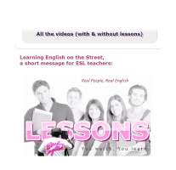

**5 + 6 Reading (May Be a 3-Part Workshop)**

**Reading Workshop 1 ‘Your Amazing Brain’**

1. Teacher asks students what difficulties they have when reading
2. Continue with comparing differences between reading in French and English
3. Teacher briefly explains reading intentions: Verify predictions and visualize
4. Teacher divides group in 2 - Each group has same text but:
   * 1. Group #1 has 5 multiple-choice-type questions to answer
     2. Group#2 has 2 summary-type questions to answer
5. After group readings, discuss which strategies students used for their tasks
6. Teacher writes strategies of each group on board for comparison
7. Teach strategies: ‘Make Predictions’ and ‘Visualising’
8. Group discusses what they liked/didn’t like about their experience

**Reading Workshop 2 (5 Reading 1) Robert Ripley Text Part 1**

1. Teacher presents the Reading 1 Workshop and the Reading Checklist Part 1 - using ‘Your Amazing Brain’ text for modelling
2. Teacher asks students to think of strategies they would like to focus on
3. Teacher shows pictures of Robert Ripley and his discoveries (from internet)
4. Students read the text (Part 1) with various types of questions to answer
5. Text correction and class discussion about the use of strategies
6. Teacher may wish to introduce the READING RESOURCES PowerPoints for students with difficulties at this point – or you may do this in Part 2

**Reading Workshop 3 (6 Reading 2) Robert Ripley Text Part 2**

1. Teacher asks if there were difficult words or parts of the text and which strategies students used to deal with this
2. Teacher presents the Reading Competency Workshop 2 and the Reading Checklist Part 2 - using ‘Robert Ripley Part 1’ for modelling
3. Teacher introduces the READING RESOURCES PowerPoints, if not already done in Part 1 of the workshop
4. Teacher hands out the text ‘Robert Ripley Part 2’
5. Students work individually or in pairs using strategies
6. Text correction and class discussion about the use of strategies
7. 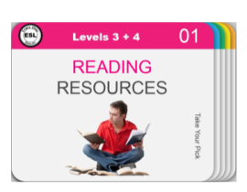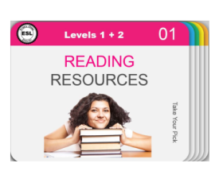Teacher invites students to choose one or more strategies they would like to work on and practise in future texts.



**7 Writing**

**This is a 2-Part Workshop**

*Writing is the one part of an evaluation where many students feel they are most in control. This is a very concrete competency, which easily lends itself to being practiced and improved. Seeing such tangible results will boost the confidence of every ESL learner. This workshop helps students to develop written communication in English, and is specific to the needs of each level.*

**Part 1 and Part 2:**

1. Note: The teacher will decide whether this two-part workshop will be undertaken in one session or at two separate times
2. **Part 1:** Have a short discussion about the importance of improving writing skills. Emphasize that for most students, working on this competency for a relatively short time can produce impressive results
3. Teacher gives presentation ‘7 Writing Competency Workshop’
4. Students use the ‘General Writing Checklist’ to follow the presentation
5. The teacher may decide to present the document ‘Spelling and Grammar Check in Microsoft Word’ at this time or during Part 2.
6. The teacher may wish to demonstrate ‘Check Document with Free Online Editor’ and experiment with The Hemmingway App. It is a good idea to use this app before presenting in class
7. Students may wish to visit some of the online activities to improve writing
8. **Part 2:** After page 9 of the presentation, the teacher will decide whether to make a second presentation (ex: 7 Writing a Postcard or Letter) specific to the writing task(s) of the students, or allow the students to view the Specific Writing Presentation on their own, with the specific checklist
9. Students generally enjoy participating in a ‘writing workshop’ following this presentation. The ‘Writing Assessments’, along with the Evaluation Grids have been created for use as an assessment tool prior to writing exams

